**Assignment No:** 12

**Name** : AKASH RAKESH METKARI

**Batch**: T6

**PRN**: 22520012

1. CSV file 'CitiesDatabase.csv' loaded, displaying the first 5 rows.

LOAD CSV WITH HEADERS FROM 'file:///CitiesDatabase.csv' AS row

RETURN row

LIMIT 5

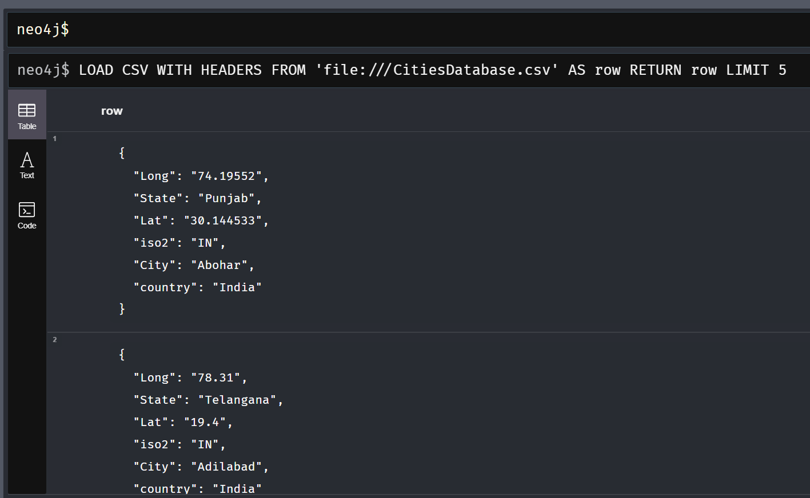

1. City data from 'CitiesDatabase.csv' used to create location nodes with city name, state, country, and coordinates.

LOAD CSV WITH HEADERS FROM 'file:///CitiesDatabase.csv' AS row

CREATE (:Location {

    city: row.City,

    state: row.State,

    country: row.country,

    coordinates: point({latitude: toFloat(row.Lat), longitude: toFloat(row.Long)})

})

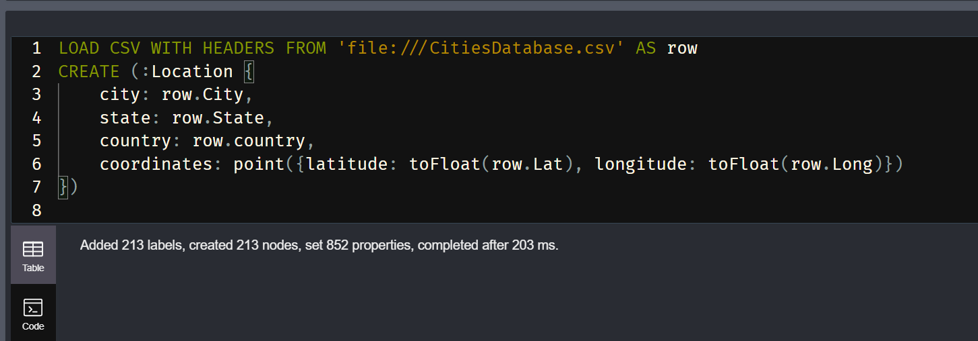

1. Using the calculated distances, the query retrieves the nearest locations to Abohar, Punjab, India, showcasing the top 5 results along with their distances.

MATCH (a:Location {city: 'Abohar', state: 'Punjab', country: 'India'})

MATCH (b:Location)

WHERE a <> b

WITH a, b, point.distance(a.coordinates, b.coordinates) AS dist

RETURN b.city AS NearestLocation, dist

ORDER BY dist

LIMIT 5

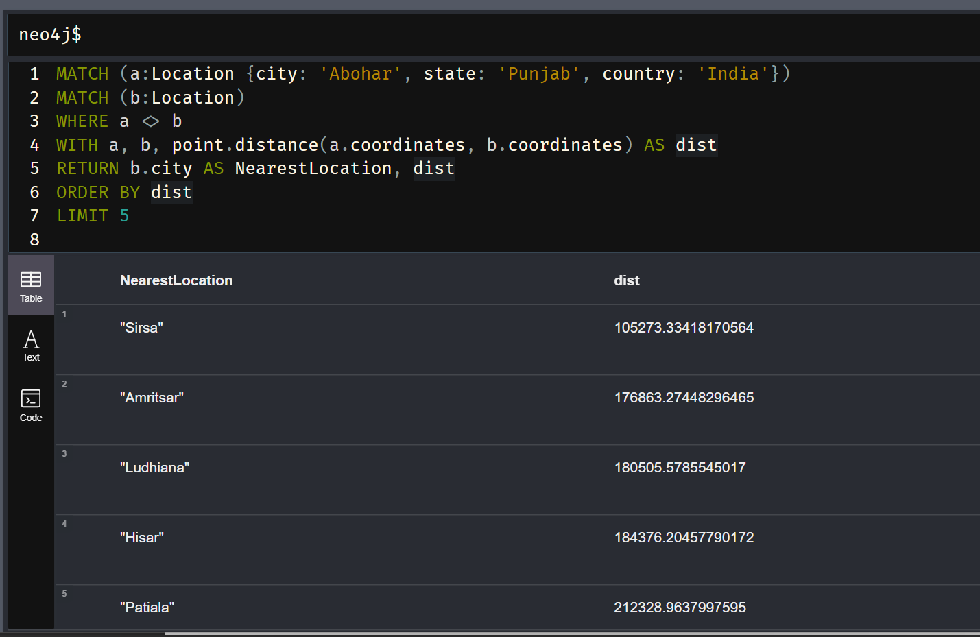

1. Nearby cities to Adilabad, Telangana, India, identified using distance calculations, presenting the top results within a distance threshold of 176863.27448 meters.

MATCH (a:Location {city: 'Adilabad', state: 'Telangana', country: 'India'})

MATCH (b:Location)

WHERE a <> b

WITH a, b, point.distance(a.coordinates, b.coordinates) AS dist

WHERE dist < 176863.27448  // Adjust the distance threshold as needed

RETURN b.city AS NearbyCity, dist

ORDER BY dist

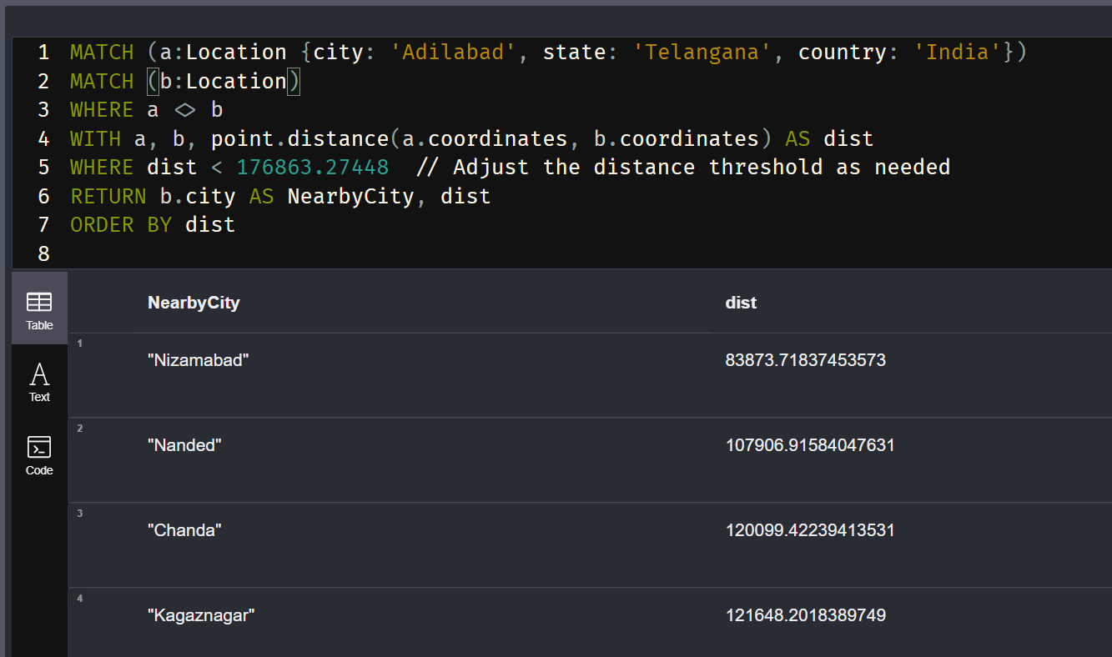

1. Query to find distance between Cities Akola and Agra

MATCH (a:Location {city: 'Akola'}), (b:Location {city: 'Agra'})

RETURN point.distance(a.coordinates, b.coordinates) AS Distance

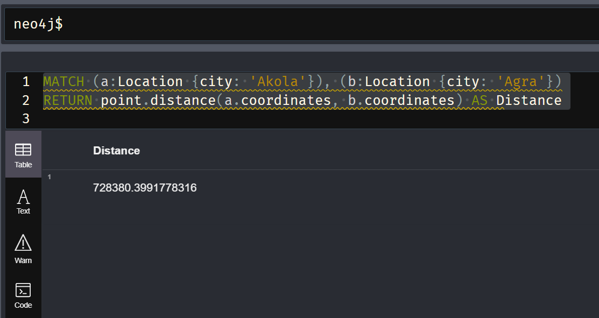

1. Query to find 5 closest cities near Mumbai

MATCH (mumbai:Location {city: "Mumbai"})

MATCH (other:Location)

WHERE other <> mumbai

RETURN other.city AS NearbyCity, point.distance(mumbai.coordinates, other.coordinates) AS Distance

ORDER BY Distance ASC

LIMIT 5

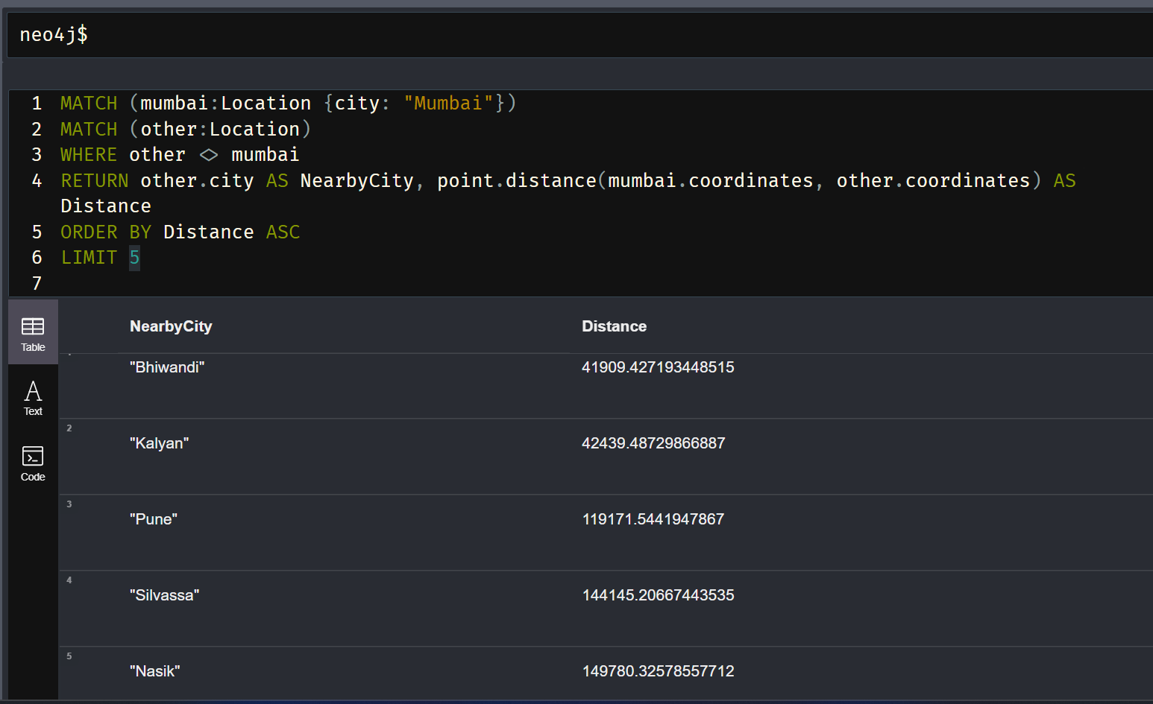

1. Cities in Maharashtra

MATCH (l:Location {state: "Maharashtra"})

RETURN COUNT(l) AS NumCities, l.city AS CityName

